## Plugins

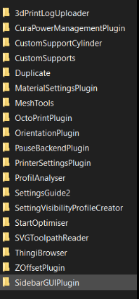

## Setting visibility

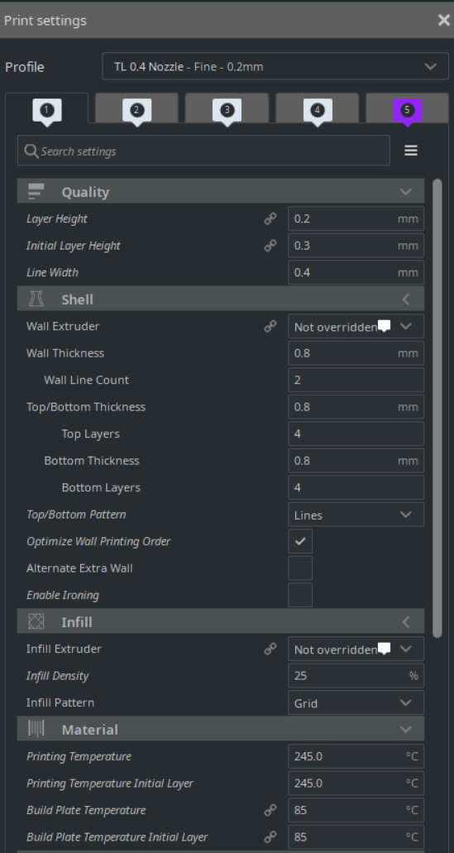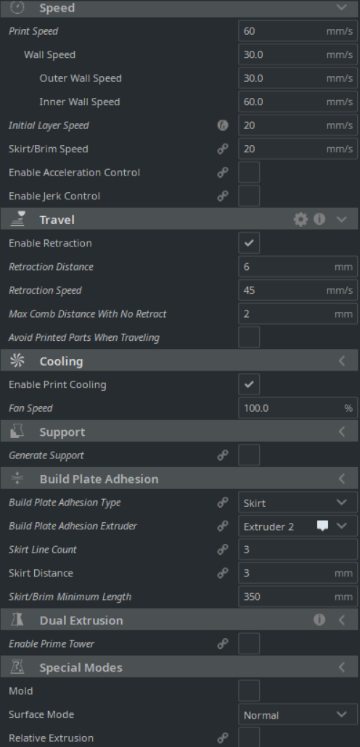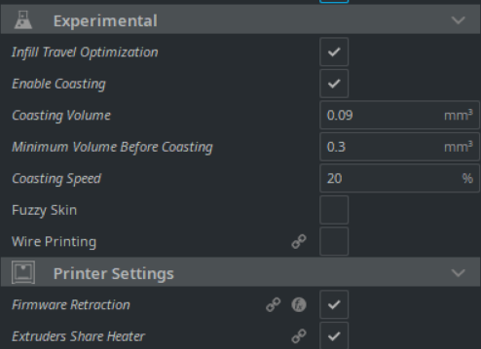

## Material Settings

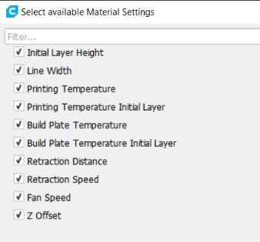

Printer

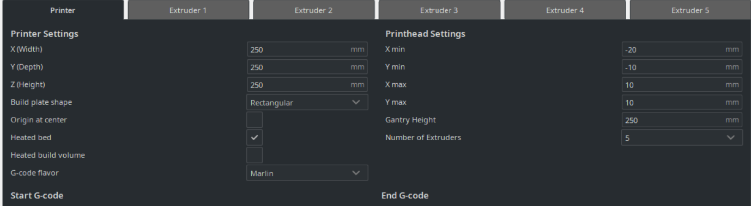

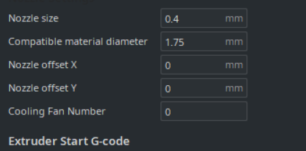

# Gcode

## Start code

;Start Script

;Octolapse script:

; --- Global Settings

; layer_height = {layer_height}

; smooth_spiralized_contours = {smooth_spiralized_contours}

; magic_mesh_surface_mode = {magic_mesh_surface_mode}

; machine_extruder_count = {machine_extruder_count}

; --- Single Extruder Settings

; speed_z_hop = {speed_z_hop}

; retraction_amount = {retraction_amount}

; retraction_hop = {retraction_hop}

; retraction_hop_enabled = {retraction_hop_enabled}

; retraction_enable = {retraction_enable}

; retraction_speed = {retraction_speed}

; retraction_retract_speed = {retraction_retract_speed}

; retraction_prime_speed = {retraction_prime_speed}

; speed_travel = {speed_travel}

; --- Multi-Extruder Settings

; speed_z_hop_0 = {speed_z_hop, 0}

; speed_z_hop_1 = {speed_z_hop, 1}

; speed_z_hop_2 = {speed_z_hop, 2}

; speed_z_hop_3 = {speed_z_hop, 3}

; speed_z_hop_4 = {speed_z_hop, 4}

; speed_z_hop_5 = {speed_z_hop, 5}

; speed_z_hop_6 = {speed_z_hop, 6}

; speed_z_hop_7 = {speed_z_hop, 7}

; retraction_amount_0 = {retraction_amount, 0}

; retraction_amount_1 = {retraction_amount, 1}

; retraction_amount_2 = {retraction_amount, 2}

; retraction_amount_3 = {retraction_amount, 3}

; retraction_amount_4 = {retraction_amount, 4}

; retraction_amount_5 = {retraction_amount, 5}

; retraction_amount_6 = {retraction_amount, 6}

; retraction_amount_7 = {retraction_amount, 7}

; retraction_hop_0 = {retraction_hop, 0}

; retraction_hop_1 = {retraction_hop, 1}

; retraction_hop_2 = {retraction_hop, 2}

; retraction_hop_3 = {retraction_hop, 3}

; retraction_hop_4 = {retraction_hop, 4}

; retraction_hop_5 = {retraction_hop, 5}

; retraction_hop_6 = {retraction_hop, 6}

; retraction_hop_7 = {retraction_hop, 7}

; retraction_hop_enabled_0 = {retraction_hop_enabled, 0}

; retraction_hop_enabled_1 = {retraction_hop_enabled, 1}

; retraction_hop_enabled_2 = {retraction_hop_enabled, 2}

; retraction_hop_enabled_3 = {retraction_hop_enabled, 3}

; retraction_hop_enabled_4 = {retraction_hop_enabled, 4}

; retraction_hop_enabled_5 = {retraction_hop_enabled, 5}

; retraction_hop_enabled_6 = {retraction_hop_enabled, 6}

; retraction_hop_enabled_7 = {retraction_hop_enabled, 7}

; retraction_prime_speed_0 = {retraction_prime_speed, 0}

; retraction_prime_speed_1 = {retraction_prime_speed, 1}

; retraction_prime_speed_2 = {retraction_prime_speed, 2}

; retraction_prime_speed_3 = {retraction_prime_speed, 3}

; retraction_prime_speed_4 = {retraction_prime_speed, 4}

; retraction_prime_speed_5 = {retraction_prime_speed, 5}

; retraction_prime_speed_6 = {retraction_prime_speed, 6}

; retraction_prime_speed_7 = {retraction_prime_speed, 7}

; retraction_retract_speed_0 = {retraction_retract_speed, 0}

; retraction_retract_speed_1 = {retraction_retract_speed, 1}

; retraction_retract_speed_2 = {retraction_retract_speed, 2}

; retraction_retract_speed_3 = {retraction_retract_speed, 3}

; retraction_retract_speed_4 = {retraction_retract_speed, 4}

; retraction_retract_speed_5 = {retraction_retract_speed, 5}

; retraction_retract_speed_6 = {retraction_retract_speed, 6}

; retraction_retract_speed_7 = {retraction_retract_speed, 7}

; retraction_speed_0 = {retraction_speed, 0}

; retraction_speed_1 = {retraction_speed, 1}

; retraction_speed_2 = {retraction_speed, 2}

; retraction_speed_3 = {retraction_speed, 3}

; retraction_speed_4 = {retraction_speed, 4}

; retraction_speed_5 = {retraction_speed, 5}

; retraction_speed_6 = {retraction_speed, 6}

; retraction_speed_7 = {retraction_speed, 7}

; retraction_enable_0 = {retraction_enable, 0}

; retraction_enable_1 = {retraction_enable, 1}

; retraction_enable_2 = {retraction_enable, 2}

; retraction_enable_3 = {retraction_enable, 3}

; retraction_enable_4 = {retraction_enable, 4}

; retraction_enable_5 = {retraction_enable, 5}

; retraction_enable_6 = {retraction_enable, 6}

; retraction_enable_7 = {retraction_enable, 7}

; speed_travel_0 = {speed_travel, 0}

; speed_travel_1 = {speed_travel, 1}

; speed_travel_2 = {speed_travel, 2}

; speed_travel_3 = {speed_travel, 3}

; speed_travel_4 = {speed_travel, 4}

; speed_travel_5 = {speed_travel, 5}

; speed_travel_6 = {speed_travel, 6}

; speed_travel_7 = {speed_travel, 7}

G28 R5 ; Autohome if unknown

M140 S{material_bed_temperature_layer_0} ; start preheating the bed

;G29 ; Bed leveling

;M207 [F<feedrate>] [S<length>] Retract length [W<length>] [Z<length>] //To Set

G90 ; Absolute Positioning

M82 ; E Absolute independant of G91 (Relative)

G92 E0 ; Set Position

G1 Z15 F1700 ; Lift up (1800 is max)

G0 X0 F6000; Go to bucket

M211 S0 ; Disable SoftStops

G0 X-5 F500; Go to bucket Closer

M211 S1 ; Enable SoftStops

M107 ; Fan Off

M412 S1 ; Enable Runout Sensor

;Set Mix for Virtual Tools

M163 S0 P0.8

M163 S1 P0.2

M163 S2 P0.0

M164 S3 ; Extruder 4

M163 S0 P0.6

M163 S1 P0.4

M163 S2 P0.0

M164 S4 ; Extruder 5

M163 S0 P0.8

M163 S1 P0.0

M163 S2 P0.2

M164 S5 ; Extruder 6

M163 S0 P0.6

M163 S1 P0.0

M163 S2 P0.4

M164 S6 ; Extruder 7

M163 S0 P0.1

M163 S1 P0.1

M163 S2 P0.8

M164 S7 ; Extruder 8

;/Virtual Tools

;/Colour mixing:

;M165 A0 B0.5 C0.5 ; Set Mix for current tool

M104 S{material_print_temperature_layer_0} ; start preheating hotend

M190 S{material_bed_temperature_layer_0} ; wait for Cura Bed setting

M109 S{material_print_temperature_layer_0} ; wait for Cura Hotend

;/Start Script

## End Code

;End Script

m106 ; Turn on Fan to try and cool retraction good for 1 layer print

G92 E0 ; Set current extruder position to 0

G10 ; Retract

G91 ; Set the interpreter to relative positions

G0 F1700 Z3 ; Lift up by 10mm (relative)

G90 ; Absolute positioning

G0 X0 F6000

M211 S0 ; Disable SoftStops

G0 X-5 F500; Go to bucket Closer

M211 S1 ; Enable SoftStops

G0 Y200 F2700 ; Move bed forward

m107 ; Fan Off

M104 S0 ; Swith off Hotend

M140 S0 ; Switch off Bed

G90 ; Absolute positioning

G92 E0 ; Set position

M84 ; Disable Steppers

;/End Script

## Extruder 1 Start

;Change Tool

M109 R{material_print_temperature}

G91 ; Relative

G1 E25 F100 ; Extrude into Bucket

G1 E5 F50 ; Slow Purge to reduce pressure

G92 E0 ; Set Extruder Position

G90 ; Absolute

G10 ; Retract

; Wait for ooze

G4 S3 ; Wait 2 seconds

G0 X5 F500 ; Wipe

G0 X-5 F4000 ; Wipe

G0 X5 F500 ; Wipe

G0 X-5 F4000 ; Wipe

M211 S1 ; Enable SoftStops

;/Change Tool

## Extruder 1 end

;Change End

G10 ; Retract

G91 ; Relative position

G0 Z0.2 F9000 ; Lift Nozzle

G0 Z1 X-5 F9000 ;lift diagonal

G90 ; Absolute

G0 X0 F6000; Go to bucket

M211 S0 ; Disable SoftStops

G0 X-5 F500; Go to bucket Closer

G11 ; Recover

;/Change End

# Octoprint

B12905F201B24472B9F45787457A5CAF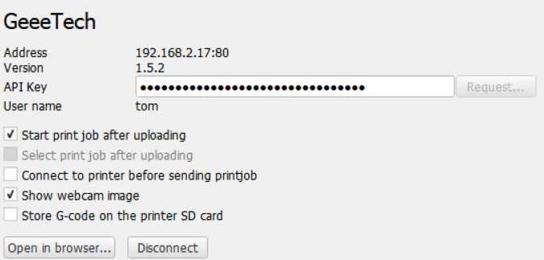

# General Settings

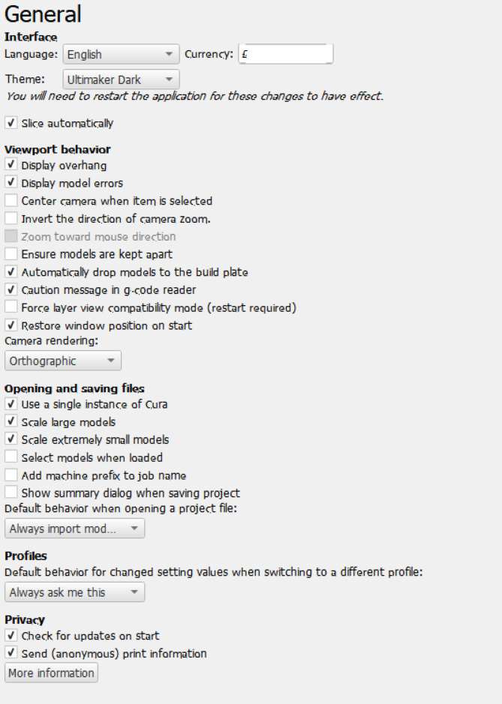

# Post Processing

|  |  |
| --- | --- |
| **Before** | **After** |
| ;/Change Tool\nG92 E0\nG10 | ;/Change Tool\n;Removed Retract G92 E0 |
| M105\nM109 | ;Remove Temp tool changes M105 followed by M109 |
| ;MESH.*\nG0 F[0-9]{3,} | ;MESH; Adjusted Speed 1:\nG0 F7200 |
| M107\n;MESH.*\nG0 F[0-9]{3,} | M107\n;Adjusted Speed 2:\nG0 F7200 |

## Path

C:\Users\Tom\AppData\Roaming\cura